Low-Level Design (LLD) — Order Booking Module
Attribute | Value
Module | Order Booking (Create / Submit Dealer Orders)
Menu path | ORDER BOOKING → Order Booking (or equivalent sidebar)
Landing page | orderbooking.php
Application | Complaint / Dealer Portal
Stack (target) | Core PHP + MySQL (PDO)
Stack (current repo) | Core PHP + PostgreSQL via PDO ($obconn, $dpconn)
Document version | 1.0
Access | RBAC module slug order-booking / permission create-order

â”€â”€â”€â”€â”€â”€â”€â”€â”€â”€â”€â”€â”€â”€â”€â”€â”€â”€â”€â”€â”€â”€â”€â”€â”€â”€â”€â”€â”€â”€â”€â”€

1. Module Overview

1.1 Purpose
Authenticated users with Order Booking create permission build a product cart and submit dealer orders. Draft lines live in tbl_vayu_cartitems (status = 0). On submit, the system inserts one plexecom_customer_units row per cart line under a shared refno, clears the cart, and (live path) posts a ProcessSalesOrder XML to ION. Success redirects to Recent Orders for the new refno.

1.2 Scope
In scope | Out of scope
Header form + product cart + submit | Order Acknowledgement list UI
Cart AJAX (add / update / delete / price) | Pending Orders / Despatch Details UIs
submitCartApi (live) + legacy submitCart | Installed Base soft-delete orders / api/order_create.php
Customer address / dealer / product Select2 | Complaint Entry
Price breakup modal (display GST/freight) | Full EDI monitoring console

1.3 High-level architecture
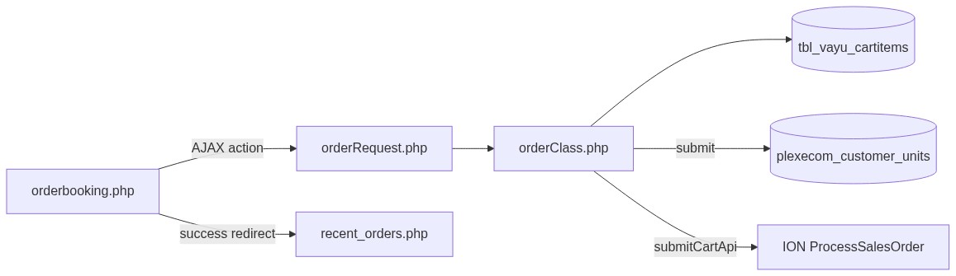
Figure 1 — High-level architecture
â”€â”€â”€â”€â”€â”€â”€â”€â”€â”€â”€â”€â”€â”€â”€â”€â”€â”€â”€â”€â”€â”€â”€â”€â”€â”€â”€â”€â”€â”€â”€â”€

2. Functional Requirements
ID | Requirement | Priority
FR-01 | User with order-booking/create-order can open booking page | Must
FR-02 | Capture header: category, area, PO, delivery date, terms, transporter, address, order type | Must
FR-03 | Search/add products to cart with qty and price | Must
FR-04 | Prevent mixed Units/Spares in one cart | Must
FR-05 | Update qty and remove cart lines | Must
FR-06 | Show cart totals and price breakup (display) | Should
FR-07 | Submit order → persist lines under new refno | Must
FR-08 | Live submit posts order to ION (submitCartApi) | Must
FR-09 | Clear draft cart after successful book | Must
FR-10 | Redirect to Recent Orders with order_no | Should
FR-11 | Dealer Engineer / ELGi Engineer: dealer Select2 for addresses | Should

â”€â”€â”€â”€â”€â”€â”€â”€â”€â”€â”€â”€â”€â”€â”€â”€â”€â”€â”€â”€â”€â”€â”€â”€â”€â”€â”€â”€â”€â”€â”€â”€

3. User Roles & Permissions

3.1 RBAC module slug
Resource | Module | Permission
orderbooking.php | order-booking | create-order

Gate: rbac_user_can($obconn, 'order-booking', 'create-order'). Denied → access_denied.php. Unauthenticated → login.php.
Sidebar uses the same page → module/permission map.

3.2 AJAX access
Resource | Gate
orderRequest.php | Session / idle / session_version only — no order-booking/create-order check

Gap: any authenticated user who can call the endpoint may invoke cart/submit actions.

3.3 Role UI differences
Role | Id | Booking UI note
Dealer User | 1 | Address via session customer (if set)
Dealer Engineer | 2 | Extra #dealerlist Select2
ELGi Engineer | 3 | Extra #dealerlist Select2
Others | 4–7 | No dealer list block (in_array([2,3]))

3.4 Customer scoping on create
Order cuno = $_SESSION['customer_number_vayu'] ?? '10001'.
Dealer list filters address search only; selected dealer is not written as booking customer on submit. Login often does not populate customer_number_vayu → frequent fallback to '10001'.
â”€â”€â”€â”€â”€â”€â”€â”€â”€â”€â”€â”€â”€â”€â”€â”€â”€â”€â”€â”€â”€â”€â”€â”€â”€â”€â”€â”€â”€â”€â”€â”€

4. Business Rules
ID | Rule
BR-01 | Draft = cart rows with created_by = usr_name and status = 0.
BR-02 | Booked lines insert immediately; no draft flag on plexecom_customer_units.
BR-03 | One shared refno per submit for all cart lines.
BR-04 | refno = E/UNITS/{YYMMDD}{4-digit nextval('dp_spares')}.
BR-05 | Cart cannot mix different order_type values (Units vs Spares).
BR-06 | Duplicate cart item merges qty/price for same item_code (+ dpst/order_type).
BR-07 | After submit, user’s active cart rows are hard-deleted.
BR-08 | Inserted line status = 'A'; edistatus = 'Y'; order_number empty at create.
BR-09 | Live UI submit uses submitCartApi; submitCart button is hidden (d-none).
BR-10 | submitCartApi forces delivery terms "CIF"; dpst Units=Y0001 / Spares=Y0011.
BR-11 | Missing product match for tplcode+dpst → line skipped (partial order possible).
BR-12 | Cart price/total_amount store line totals (qty × unit), not unit alone.
BR-13 | Display freight ≈ 4% of base; CGST/SGST 9%/9% in cart UI (display breakup).
BR-14 | Order Category UI locked Standard (1); Payment Term UI locked Advance (804).
BR-15 | emp_code hardcoded "102464" on insert.
BR-16 | Empty cart submit → Cart is empty.
BR-17 | Success → SuccessModal then recent_orders.php?order_no={refno}.

â”€â”€â”€â”€â”€â”€â”€â”€â”€â”€â”€â”€â”€â”€â”€â”€â”€â”€â”€â”€â”€â”€â”€â”€â”€â”€â”€â”€â”€â”€â”€â”€

5. Database Design

5.1 ER / logical model
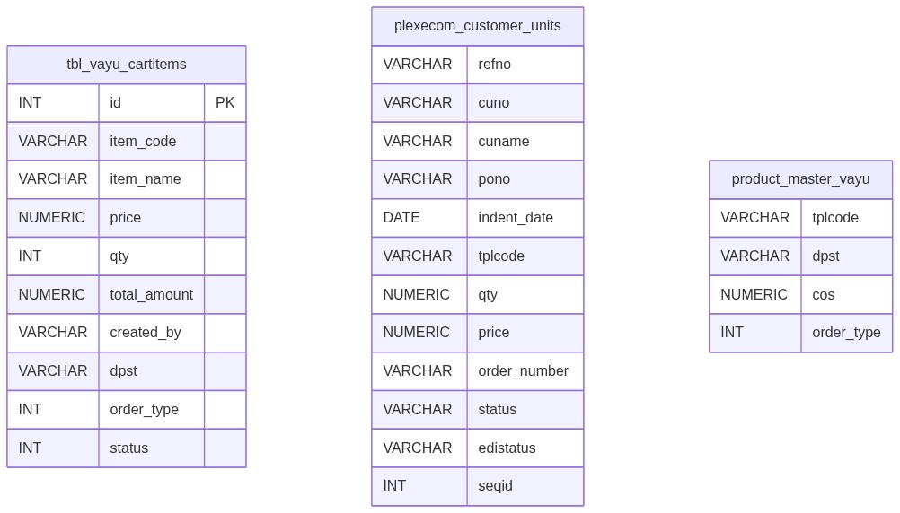
Figure 2 — Entity relationship diagram
Figure 3 — Cart to booked lines flow

5.2 Tables
Table | Conn | Role
tbl_vayu_cartitems | $obconn | Draft cart (status = 0)
plexecom_customer_units | $obconn | Booked order lines
product_master_vayu | $obconn | Item search / price / attrs
area, transporter_master, customer_address, customer_master | ob/dp | Header lookups
dpst_master, elgi_item_master, gst_hsn, user_master | $obconn | Indent / HSN / tax / EDI email
Sequences dp_spares, plexecom_unique_sequence | $obconn | refno serial / seqid

5.3 Booked line key fields (create)
Field | Notes
refno | Shared booking id
cuno / cuname | Customer
pono, indent_*, delivery_date | Header
tplcode, tpldesc, qty, price, dpst | Line
status | 'A'
edistatus | 'Y'
order_number | Empty until acknowledgement

5.4 Pipeline relation (downstream)
Metric | Definition
Created | Distinct refno
Acknowledged | order_number (AO) non-empty
Pending | AO empty
Dispatched | AO matches despatch.ordno

â”€â”€â”€â”€â”€â”€â”€â”€â”€â”€â”€â”€â”€â”€â”€â”€â”€â”€â”€â”€â”€â”€â”€â”€â”€â”€â”€â”€â”€â”€â”€â”€

6. API / Backend Design

6.1 Page endpoints
Endpoint | Method | Auth | Description
orderbooking.php | GET | order-booking/create-order | Booking UI

6.2 AJAX router — POST orderRequest.php
Action | Description
searchItems | Product Select2
getPrice | Unit price + order-type guard
addItem | Insert/merge cart line
getCartItems | Render cart HTML
updatePrice | Update qty/total
deleteItem | Hard-delete cart row
getCartPriceBreakup / getCartOrderPriceBreakup | Display GST/freight
customer_master | Address Select2
search_dealer | Dealer Select2 ($dpconn)
submitCart | DB-only book (UI hidden)
submitCartApi | Book + ION (live button)

6.3 Not this module
api/order_create.php / orders soft-delete table = Installed Base–style orders — different subsystem.

6.4 Core PHP responsibilities
File | Role
orderbooking.php | Page shell, RBAC, inline JS UI
orderRequest.php | Action router
orderClass.php | Cart, submit, EDI, lookups
pdo_obconn.php | $obconn / $dpconn
includes/rbac_access_helpers.php | Page/menu AuthZ
js/success_modal.js / js/pincode_select2.js | Success UX / pincode

â”€â”€â”€â”€â”€â”€â”€â”€â”€â”€â”€â”€â”€â”€â”€â”€â”€â”€â”€â”€â”€â”€â”€â”€â”€â”€â”€â”€â”€â”€â”€â”€

7. Validation Rules

7.1 Client-side (orderbooking.php)
Context | Messages (examples)
Add item | Please select an item · Please enter a quantity · Please enter a price · Please select a order type · Please check the quantity
Submit header | Please select a order category · Please select a delivery term · Please select a payment term · Please select a transporter · Please select area · Please select delivery date · Please enter PO Number · Please select ordertype
Address / end customer | Please select an address · Please enter name · Please enter email · Please enter street 1 · Please select pincode · Please enter city/district/state · Please enter a valid email address
Fail | Error in placing order ! Please contact IT · Unable to fetch price breakup.

7.2 Server-side (orderClass)
Rule | Message
Empty cart | Cart is empty.
Order category (submitCart) | Order category is required.
Mixed order types | Items with different order types cannot be added to the same cart...
Insert fail | Failed to insert order item / Error in request
Price breakup | Invalid cart item. · Cart item not found. · No cart items found.

Gap: most header fields (area, PO, transporter, email, etc.) are client-only; server largely trusts POST.
â”€â”€â”€â”€â”€â”€â”€â”€â”€â”€â”€â”€â”€â”€â”€â”€â”€â”€â”€â”€â”€â”€â”€â”€â”€â”€â”€â”€â”€â”€â”€â”€

8. UI Screen Specifications

8.1 Booking page — orderbooking.php
Element | Spec
Header card | Category, area, PO, delivery date, delivery terms, payment term, transporter, address type, order type
Product card | Item Select2, qty, price, Add Item
Cart section | Custom HTML table #cartTable (not DataTables)
Submit | Submit Order Api (live); Submit Order hidden
Modal | #priceBreakupModal line/order breakup
Date | jQuery UI datepicker #dDate (dd.mm.yy, minDate: 0)
Locked fields | Order Category Standard; Payment 100% Advance (804)

8.2 Select2 controls
Control | Purpose
Item search | Products from product_master_vayu
Customer address | Ship-to / invoice address
Dealer list | Roles 2/3 only
Transporter / Area / Delivery term | Header
Pincode | End-customer city/district/state (pincode_select2.js)

8.3 Success UX
SuccessModal: title Order Created Successfully; message Your order has been created successfully.; then redirect recent_orders.php?order_no=.
â”€â”€â”€â”€â”€â”€â”€â”€â”€â”€â”€â”€â”€â”€â”€â”€â”€â”€â”€â”€â”€â”€â”€â”€â”€â”€â”€â”€â”€â”€â”€â”€

9. Database Flow

9.1 Submit (live submitCartApi)
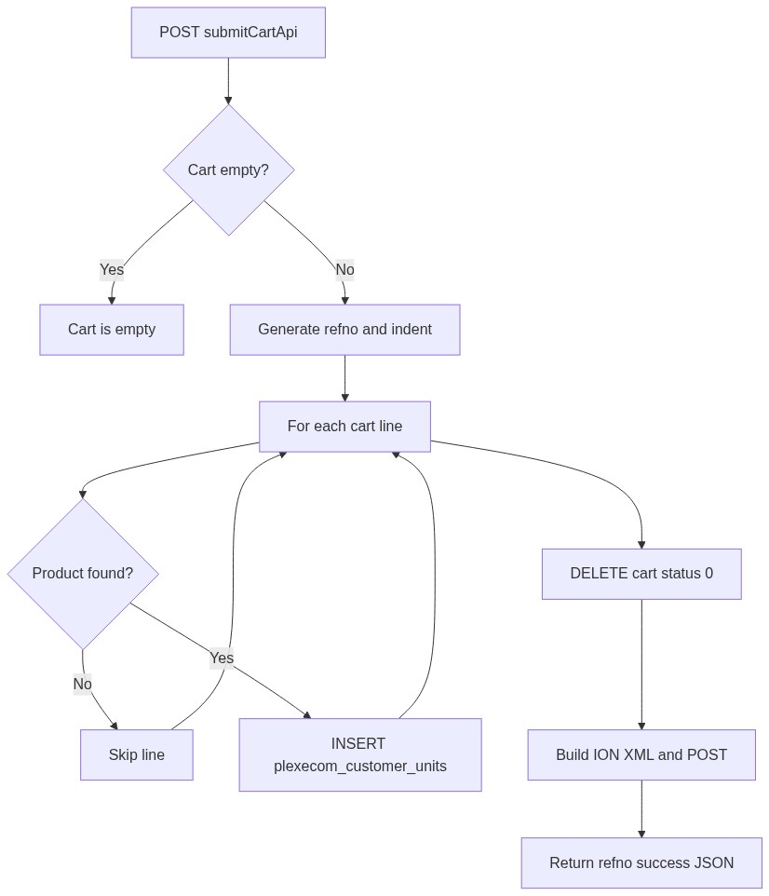
Figure 4 — Submit database flow

9.2 Cart draft
-- Active draft lines for user
SELECT * FROM tbl_vayu_cartitems
WHERE created_by = :usr_name
AND status = 0;

9.3 Clear cart after book
DELETE FROM tbl_vayu_cartitems
WHERE created_by = :usr_name
AND status = 0;
â”€â”€â”€â”€â”€â”€â”€â”€â”€â”€â”€â”€â”€â”€â”€â”€â”€â”€â”€â”€â”€â”€â”€â”€â”€â”€â”€â”€â”€â”€â”€â”€

10. Sequence Diagram

10.1 Add to cart
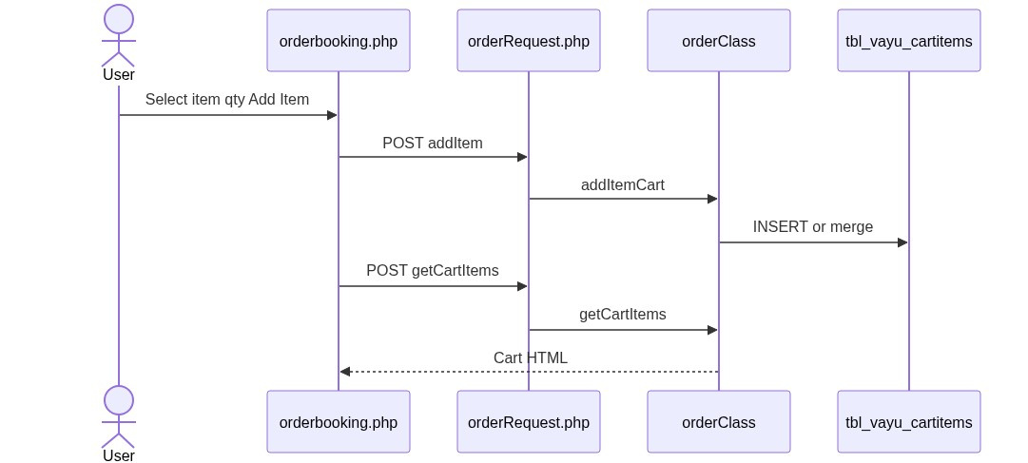
Figure 5 — Sequence: Add to cart

10.2 Submit via API
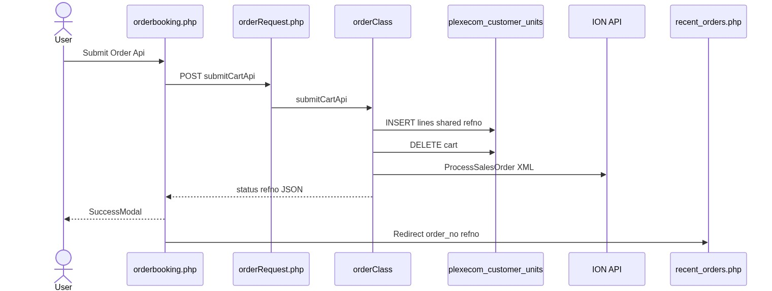
Figure 6 — Sequence: Submit via API
â”€â”€â”€â”€â”€â”€â”€â”€â”€â”€â”€â”€â”€â”€â”€â”€â”€â”€â”€â”€â”€â”€â”€â”€â”€â”€â”€â”€â”€â”€â”€â”€

11. Activity Diagram
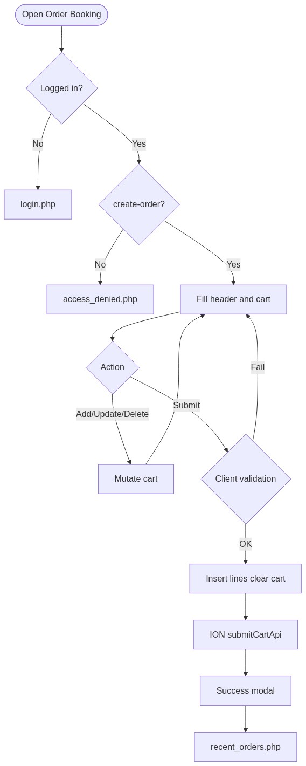
Figure 7 — Activity diagram
â”€â”€â”€â”€â”€â”€â”€â”€â”€â”€â”€â”€â”€â”€â”€â”€â”€â”€â”€â”€â”€â”€â”€â”€â”€â”€â”€â”€â”€â”€â”€â”€

12. Class / Module Diagram
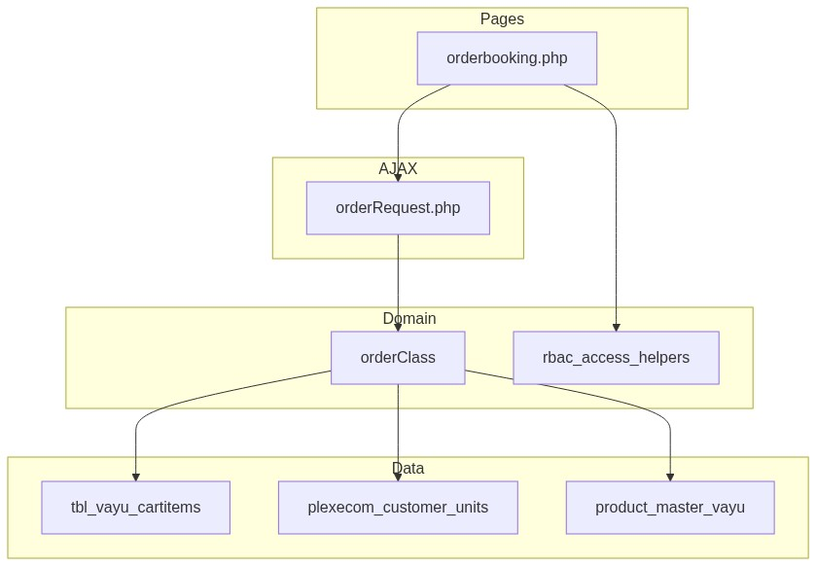
Figure 8 — Class / module diagram

12.1 Key functions (orderClass)
Function | Role
searchItems | Product Select2
getPrice | Unit price + mixed-type guard
addItemCart | Insert/merge cart
getCartItems | Cart HTML + totals
deleteItem / updatePrice | Cart mutations
getCartPriceBreakup / getCartOrderPriceBreakup | Display breakup
submitCart | DB-only book
submitCartApi | Book + ION
customer_master / search_dealer | Address / dealer Select2

â”€â”€â”€â”€â”€â”€â”€â”€â”€â”€â”€â”€â”€â”€â”€â”€â”€â”€â”€â”€â”€â”€â”€â”€â”€â”€â”€â”€â”€â”€â”€â”€

13. Folder Structure
ComplaintManagement/
├── orderbooking.php
├── orderRequest.php
├── orderClass.php
├── recent_orders.php
├── access_denied.php
├── pdo_obconn.php
├── includes/
│ ├── rbac_access_helpers.php
│ ├── admin_access_helpers.php
│ └── login_helpers.php
├── css/
│ ├── orderbook_style.css
│ ├── success_modal.css
│ └── select2_change.css
├── js/
│ ├── success_modal.js
│ └── pincode_select2.js
└── docs/
└── LLD_Order_Booking_Module.md
â”€â”€â”€â”€â”€â”€â”€â”€â”€â”€â”€â”€â”€â”€â”€â”€â”€â”€â”€â”€â”€â”€â”€â”€â”€â”€â”€â”€â”€â”€â”€â”€

14. Error Handling
Layer | Pattern
Page access | Redirect login / access_denied
AJAX | JSON {status, message} (shapes vary by action)
Empty cart | Cart is empty.
Submit fail | Client alert Error in placing order ! Please contact IT
Success | SuccessModal (no session flash)
Exceptions | Often appended to JSON message (class may display_errors)

14.1 Common messages
Message | When
Item Added Successfully | Cart add OK
Unable to Add Item | Cart add fail
Cart is empty. | Submit with no lines
Items with different order types cannot be added... | Mixed Units/Spares
Order Created Successfully | SuccessModal title
Your order has been created successfully. | SuccessModal body

â”€â”€â”€â”€â”€â”€â”€â”€â”€â”€â”€â”€â”€â”€â”€â”€â”€â”€â”€â”€â”€â”€â”€â”€â”€â”€â”€â”€â”€â”€â”€â”€

15. Security Considerations
Area | Control
Page AuthZ | RBAC order-booking/create-order
AJAX AuthZ gap | orderRequest.php lacks create-order check
Cart IDOR | deleteItem / updatePrice do not verify created_by
Customer fallback | Missing customer_number_vayu → cuno = '10001'
Dealer-on-behalf | UI dealer list does not set submit cuno
Header trust | Most required fields validated client-side only
Partial book | Missing product lines skipped silently
EDI | DB commit/cart clear before ION success handling; XML escaping weak; env credentials
Secrets | DB credentials in pdo_obconn.php; display_errors in orderClass.php
CSRF | Not implemented on AJAX POSTs

â”€â”€â”€â”€â”€â”€â”€â”€â”€â”€â”€â”€â”€â”€â”€â”€â”€â”€â”€â”€â”€â”€â”€â”€â”€â”€â”€â”€â”€â”€â”€â”€

16. Audit Logs

16.1 Built-in field-level audit
Item | Behavior
Cart created_by | Session username
Booked usr_name / indent_date / order_time | On insert
edistatus / edi_date | EDI-related fields on create path
Dedicated booking audit table | Not implemented
Downstream AO / despatch | Owned by Acknowledgement / Despatch modules

â”€â”€â”€â”€â”€â”€â”€â”€â”€â”€â”€â”€â”€â”€â”€â”€â”€â”€â”€â”€â”€â”€â”€â”€â”€â”€â”€â”€â”€â”€â”€â”€

17. Test Cases

17.1 Functional
ID | Scenario | Expected
TC-01 | Guest opens orderbooking.php | Redirect login
TC-02 | User without create-order | access_denied.php
TC-03 | Add item without qty | Client validation
TC-04 | Add Units then Spares item | Blocked mixed-type message
TC-05 | Add duplicate item | Qty/price merged
TC-06 | Update qty / delete line | Cart updates
TC-07 | Submit empty cart | Cart is empty.
TC-08 | Submit valid cart via API | Lines inserted; cart cleared; SuccessModal; redirect Recent Orders
TC-09 | Product missing for line | Line skipped; others may still book
TC-10 | Role 2/3 sees dealer Select2 | Dealer list shown
TC-11 | Session without customer_number_vayu | cuno defaults to 10001
TC-12 | Price breakup modal | Returns display GST/freight JSON
TC-13 | Hidden submitCart path | DB-only book if invoked
TC-14 | User without page perm but hits orderRequest | Gap: may still mutate cart if session valid

â”€â”€â”€â”€â”€â”€â”€â”€â”€â”€â”€â”€â”€â”€â”€â”€â”€â”€â”€â”€â”€â”€â”€â”€â”€â”€â”€â”€â”€â”€â”€â”€

18. Assumptions & Dependencies

18.1 Assumptions
1. order-booking/create-order is assigned to roles that may book.
2. Live production submit path is submitCartApi (ION-integrated).
3. Cart status = 0 means active draft; booked truth is plexecom_customer_units.
4. Downstream AO/despatch modules populate order_number / despatch matching later.
5. Installed Base orders / api/order_create.php remain a separate subsystem.
6. Document target stack Core PHP + MySQL; repo runs PostgreSQL sequences/CURRENT_DATE.
7. customer_number_vayu should be set at login for correct tenant scoping (known gap today).

18.2 Dependencies
Dependency | Purpose
RBAC / Assign Permissions | order-booking/create-order
product_master_vayu | Catalog / price
Area / transporter / address / customer masters | Header lookups
$obconn / $dpconn | Order DB / dealer DB
ION ProcessSalesOrder | External book (submitCartApi)
Recent Orders page | Post-success landing
Select2 + jQuery UI + SuccessModal | UI

â”€â”€â”€â”€â”€â”€â”€â”€â”€â”€â”€â”€â”€â”€â”€â”€â”€â”€â”€â”€â”€â”€â”€â”€â”€â”€â”€â”€â”€â”€â”€â”€

Appendix A — Success UX
Element | Value
Modal title | Order Created Successfully
Modal message | Your order has been created successfully.
Redirect | recent_orders.php?order_no={refno}
Session flash | None

â”€â”€â”€â”€â”€â”€â”€â”€â”€â”€â”€â”€â”€â”€â”€â”€â”€â”€â”€â”€â”€â”€â”€â”€â”€â”€â”€â”€â”€â”€â”€â”€

Appendix B — Select2 control map
Control | Select2?
Item / Address / Dealer / Transporter / Area / Delivery term / Pincode | Yes
Order Category / Payment Term (locked) | Native / readonly

â”€â”€â”€â”€â”€â”€â”€â”€â”€â”€â”€â”€â”€â”€â”€â”€â”€â”€â”€â”€â”€â”€â”€â”€â”€â”€â”€â”€â”€â”€â”€â”€

Appendix C — submitCart vs submitCartApi
Aspect | submitCart (hidden) | submitCartApi (live)
ION EDI | No | Yes
paycode | Forced 301 | From POST
delterms | From POST | Forced CIF
dpst | 90092 | Units Y0001 / Spares Y0011
Company / series / warehouse | Fixed 401 / 501 / 257 | Units 401/YUU/Y57; Spares 490/YUS/102
Success JSON | {status:'success', order_no} | {status: refno}

â”€â”€â”€â”€â”€â”€â”€â”€â”€â”€â”€â”€â”€â”€â”€â”€â”€â”€â”€â”€â”€â”€â”€â”€â”€â”€â”€â”€â”€â”€â”€â”€

Appendix D — Cart vs booked lifecycle
Stage | Storage | Status
Draft | tbl_vayu_cartitems | status = 0
Booked | plexecom_customer_units | line status = 'A'; AO empty
Acknowledged | same table | order_number set
Dispatched | + despatch | AO matches ordno

â”€â”€â”€â”€â”€â”€â”€â”€â”€â”€â”€â”€â”€â”€â”€â”€â”€â”€â”€â”€â”€â”€â”€â”€â”€â”€â”€â”€â”€â”€â”€â”€

Appendix E — Booking AJAX action list
addItem, searchItems, itemSync, getCartItems, deleteItem, updatePrice, getPrice, getCartPriceBreakup, getCartOrderPriceBreakup, customer_master, search_dealer, submitCart, submitCartApi
â”€â”€â”€â”€â”€â”€â”€â”€â”€â”€â”€â”€â”€â”€â”€â”€â”€â”€â”€â”€â”€â”€â”€â”€â”€â”€â”€â”€â”€â”€â”€â”€
End of LLD — Order Booking Module

